Part (iii):
Input:
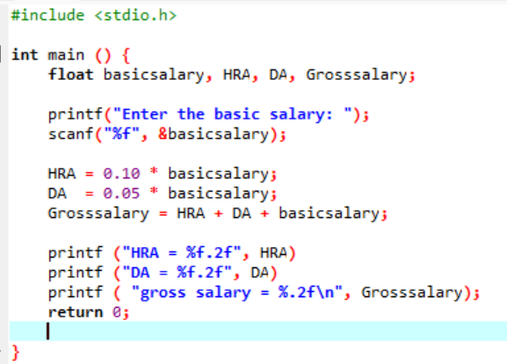
Output:
